**Admin Console Screenshots for failed test cases**

Host Management

|  |  |  |  |  |
| --- | --- | --- | --- | --- |
| **Description** | **Test Steps** | **Expected Output** | **Test Status** | **Comments** |
| Verify filter section functionality | 1. Navigate to the host management section. 2. Click on the "Filter" section/button. | A dropdown menu should open, displaying all entities available for filtering. | **Fail** | Advanced filter functionality is not implemented on the Host Management page. Only basic search is available. |

|  |  |  |  |  |
| --- | --- | --- | --- | --- |
| **Description** | **Test Steps** | **Expected Output** | **Test Status** | **Comments** |
| Verify validation for missing entity selection | 1. Navigate to the host creation page. 2. Enter host name and email but do not select an entity. 3. Click the "Submit" button. | A validation message should appear indicating that an entity must be selected. | **Fail** | Validation for entity selection is not working as expected.  When the host name and email are entered without selecting an entity, the form allows submission without displaying a validation message. There is not option to select an entity. |

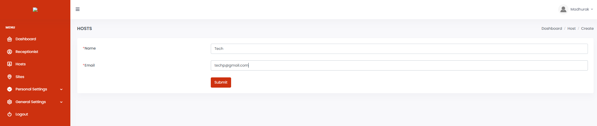

General Setting

|  |  |  |  |  |
| --- | --- | --- | --- | --- |
| **Description** | **Test Steps** | **Expected Output** | **Test Status** | **Comments** |
| Verify prevention of invalid file type in image fields | 1. Navigate to the site settings page. 2. Attempt to upload a video or audio file in an image field. 3. Click the 'Submit' button. | The application should prevent the upload and display an error message indicating invalid file type. | **Fail** | Any file type (.docx, .pdf, .txt, .csv, .gz, .rar)  is being accepted and the message 'Site settings have been updated successfully' is being displayed on clicking the 'Submit' button |

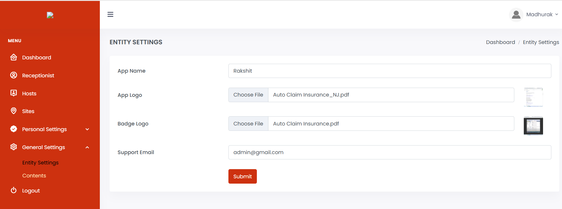

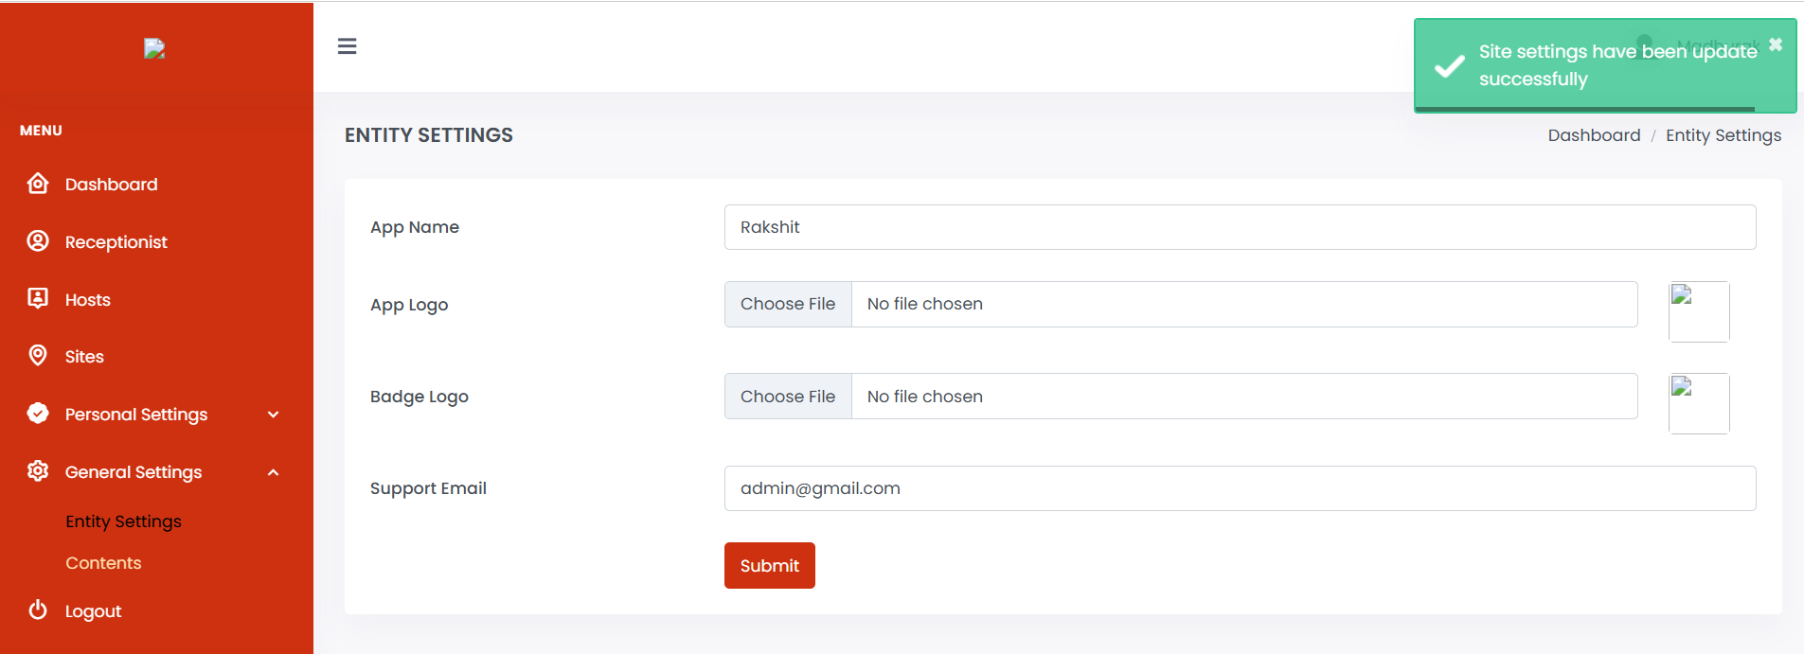

|  |  |  |  |  |
| --- | --- | --- | --- | --- |
| **Description** | **Test Steps** | **Expected Output** | **Test Status** | **Comments** |
| Verify validation for invalid email format | 1. Navigate to the site settings page. 2. Enter an invalid email address in the email field. 3. Click the 'Submit' button. | A validation message should appear indicating the invalid email format, and the settings should not be updated. | **Fail** | (User@gmail, .john@example.com)-> Accepted   (User.gmail.com, @gmail.com, gmail.com, user@, user yahoo.com,  .john@yahoo.com, john@-domain.com, john@.com  john..doe@example.com, john@.com, john@domain-.com, john@  john@domain..co.uk, user) -> Please enter a valid email address |

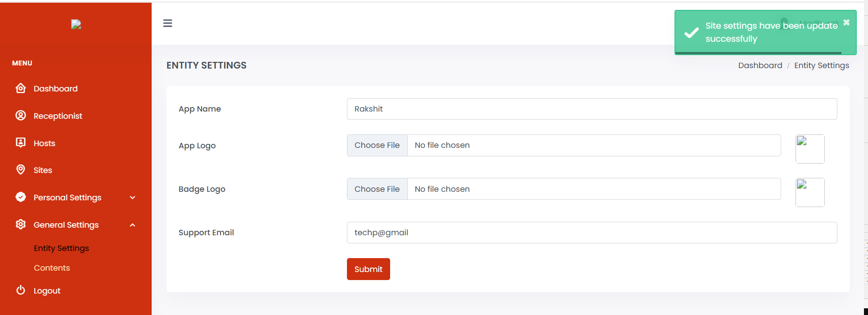

Logout

|  |  |  |  |  |
| --- | --- | --- | --- | --- |
| **Description** | **Test Steps** | **Expected Output** | **Test Status** | **Comments** |
| Verify after clicking on the back button and perfrom any action | 1. Click on the back button 2. Click on any of the option | User is logged out from the admin panel and redirected to the login page. | **Fail** | When 'Logout' button is clicked, user is redirected to login page. And, when the back button is clicked and changes are made, for example, to the Site Name and 'Submit' button is clicked, the following alert message is displayed:   DataTables warning: table id=users-table - Invalid JSON response. For more information about this error, please see http://datatables.net/tn/1  Subsequent operations are not performed and user is redirected to login page. |

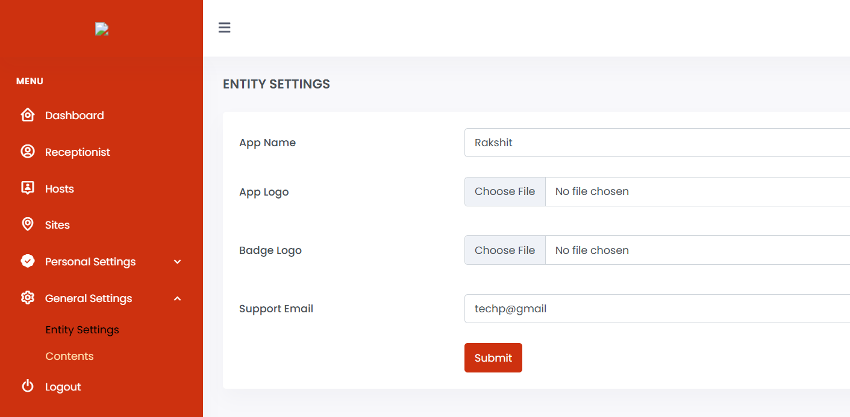

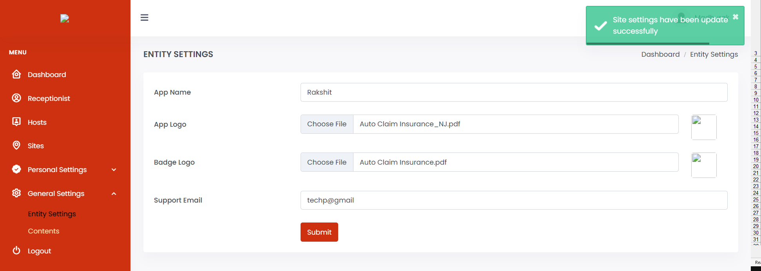

When logout button is clicked

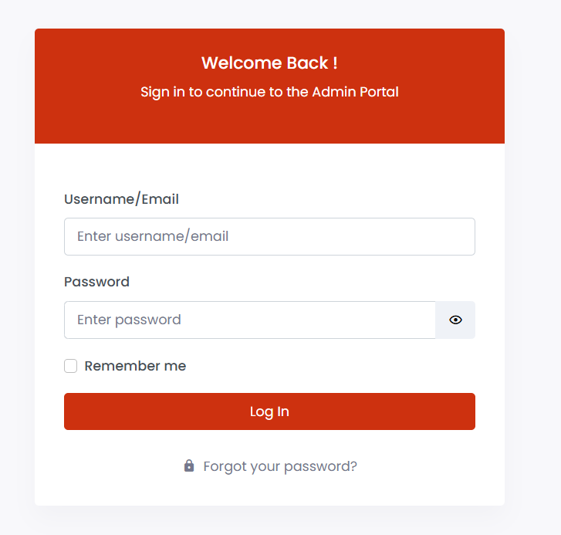

When back button is clicked

